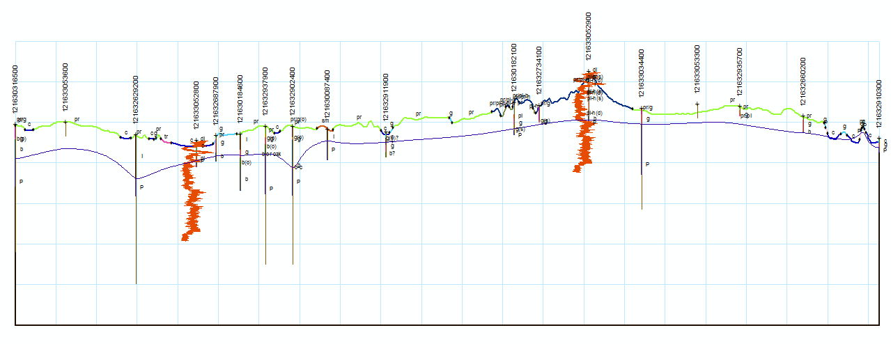
X-section
acto
User Guide
Before you run the program
- Required software: ArcGIS 10.0 (a 9.3 version is also available), any license level, and 3-D Analyst extension. The extension must be turned on (Tools > Extensions).
- In ArcMap under the menu Tools > Options, make sure the box is checked to “Add results of geoprocessing operations to the display.”
- Add the input GIS layers to the map document (.mxd). The minimum required layers are an elevation raster (DEM) and a cross section line layer.
- The input points, lines, and polygons can be in either geodatabase or shapefile format. The DEM should be in GRID format. Success has also been had with .img rasters.
- All inputs should have the same coordinate system. The coordinate system cannot be geographic (lat./long.).
- !!! Set the data frame coordinate system to match your DEM. The output shapefiles will have the same projection as the data frame.
- All file names and folder names, including those that are part of the output path, cannot contain spaces or special characters.
- The cross section line layer’s attribute table must contain a field with unique cross section names. This must be in addition to the automatically generated OID/FID and Length fields. I recommend that this field be a string field. Spaces and special characters, e.g. apostrophes, are not allowed in cross section names in the table or in the user form.
- There can be no grouped layers or topology layers in the map.
- If you are plotting well geologic data, the table with the data must be in Dbase IV (.dbf) format, and it must have a field in common with the point layer, e.g. API_number. This is because a table join is performed during the process.
- If you are plotting downhole geophysical data, each log file should be a tab-delimited text file with the extension “.LAS,” (note this is not the same format as Lidar LAS). The LAS file name should match the ID of its corresponding well/boring. In the main body of the file, the first value in a line of data is depth and the second value is gamma or other measurement. The program ignores header information and starts reading the file after it encounters the “~A” flag.
- The cross section line should lie completely within the DEM boundary. Zoom in to make sure. Edit the line if necessary.
- If you are working with geodatabase feature classes, and you have field names that are greater than 10 characters in length, the output field names will be truncated to 10 characters (the maximum length allowed for shapefiles). Make sure that the first 10 characters of a required input field are not identical to the first 10 characters of any other field in the table. Otherwise, the program may use the wrong field.
After you run the program
- To view the profile after running the program, click “Yes” when the program prompts you to add a new data frame and shapefiles to the map. The layers are automatically symbolized and labeled. Line layers are assigned random colors.
- If you want to add the shapefiles to ArcMap manually, make sure the coordinate system of the data frame matches the coordinate system of the shapefiles. If these do not match, the cross section may not have the correct dimensions.
- The final output shapefiles will have the following names:
“[xsec name] _profile” the topographic profile created from the DEM
“[xsec name] _geopts” the geologic contact points on the profile
“[xsec name] _wellpt” the well and boring points on the profile
“[xsec name] _wellln” the wells extruded as multiple lines into the subsurface, coded with geological units
“[xsec name] _[surface]” the profiles of additional raster surfaces
“[xsec name] _depths” the wells extruded as single line to (total) depth
“[xsec name] _geophys” geophysical log graphs
“[xsec name] _GridLine” reference grid lines for linear measure (X) and elevation (Y). The default input parameters yield a 1-inch by 1-inch grid for a 1:24,000-scale map, i.e., 1 inch = 2,000 feet horizontally; 1 inch = 100 feet vertically, at 20x vertical exaggeration.

- In addition to the shapefiles listed above, the program creates temporary shapefiles and tables during processing. If the program is interrupted before finishing, such as due to an error, these files will not be deleted. You will have to delete them manually from your .mxd and output folder.
- If you are exporting the cross section to Illustrator, make sure the map scale is set to 1:24,000 (or whatever scale the geologic map will be published at) before you do so. This will insure accurate length and width.
- If you run the program more than once, give the cross section a new name each time, and/or delete the existing shapefiles and tables before running it again. You may get an error if the program tries to overwrite an existing file.

Tips
- Using files located on your hard drive, rather than on the network, will significantly improve processing speed.
- Create a separate shapefile for points where the cross section line intersects roads, streams, and other features. To plot the features on the profile, run the program as if plotting well points.
- If your cross section begins or ends at a data point, extend the cross section line a short distance beyond the point. This will prevent the extruded well lines from being obscured by the axis.
Troubleshooting
Problem | Possible Solutions
The program gives an error message. | Make sure you follow the guidelines outlined above for setting up your data and naming files.
 | Give the cross section a different name.
 | Close ArcCatalog and the Visual Basic editor before running again.
 | If the error persists, close and restart ArcMap.
 | Use shapefiles rather than geodatabase features.
 | Use a string (not number) field for the line identifier input field.
Error: “must not contain Z values” | Make sure the input line does not contain Z or M values.
One or more of the output profile segments has an incorrect geologic code. | This results when a tiny sliver of a polygon intersects the cross section line, returning a false contact point. Recode the line segment manually, or edit the polygons and run the program again.
Only part of the cross section draws. | Deselect all polygons. Only the line should be selected.
The output cross section starts at the wrong end, resulting in a mirror image of what it should be. | Change the input parameter for “Start of line is located at.”


