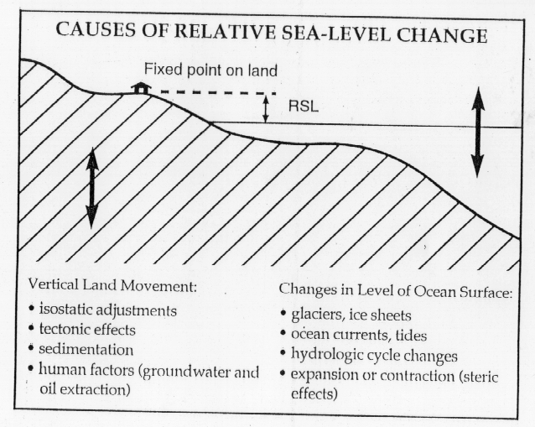

http://www.geology.iastate.edu/gcp/sealevel/sealevel_lecture.html

Eustatic Sea Level Change Mechanisms

Eustatic sea-level changes occur on an oceanic to worldwide scale.

They result from either a change in the volume of seawater, or a change in the size of the ocean basin that contains it.

Even in these large-scale cases, however, mean sea level can vary from place to place due to local tectonic and hydrographic effects.

Several processes that can cause worldwide changes in sea level are listed below.
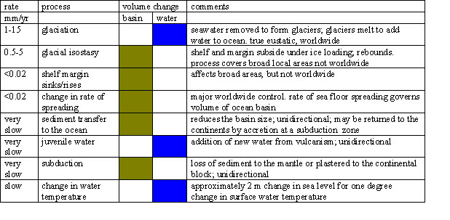

http://geology.uprm.edu/Morelock/eustatic.htm

Eustatic Sea Level Change Mechanisms

Glaciation
Despite a growing amount of data, we are still have basic questions about glacially driven sea-level change, including the amount of rise and fall and the cause of glacial cycles. The astronomic control of glaciation proposed by Milankovitch ¹⁹⁴¹ has been generally accepted to explain Pleistocene glacial cycles. The concept is that the nature of earth's orbit around the sun plays a primary role in patterns of glaciation and and, therefore, sea level change. The amount of solar radiation reaching the earth at any latitude or season is determined by three aspects of the position of the earth in its orbit around to the sun. These include:
- the eccentricity of the earth's orbit,
- the tilt of the earth's axis relative to the orbital plane, and
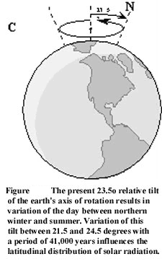
- seasonal changes in the time when the earth is most proximal to the sun (precession).
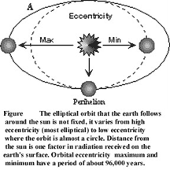
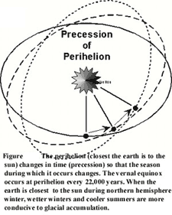

Eustatic Sea Level Change Mechanisms

Tectonics

Crustal movements may be local or global in scale.
For example, tectonic activity along mid-ocean ridges will cause eustatic sea-level changes that are expressed worldwide.
The most common tectonic mechanism to impact global sea-level change is the movement of the earth's lithospheric plates.
This includes the opening and closing of major ocean basins,
the addition of new crust along mid-ocean ridges,
and changes in continental or plate margins with subduction and isostatic adjustments to loading by new crustal material.
At the same time, volcanic activity along the mid-ocean ridges (as well as subaerial vulcanism) releases juvenal water that is released from the rock during extrusion.

http://geology.uprm.edu/Morelock/eustatic.htm

